Parth Babbar

core banking system

Introduction:
Core banking systems are centralized platforms that handle bank operations and give a uniform picture of customer accounts, processing activities such as deposits, withdrawals, loans, and payments in real time. These systems are critical for banks because they provide the infrastructure required for account management and transaction processing. In the United States, basic banking systems have developed to incorporate new technology that increase efficiency, security, and customer experience.
Features:
Core banking systems (CBS) are centralized platforms that enable banks' common transactions and operations, and they handle many services, including:
- Real-time Transaction Processing: Automatically updates account balances and transaction information.
- Customer Relationship Management (CRM): Offers solutions for managing customer interactions and data.
- Deposit and Loan Processing: Automatically handles deposits, withdrawals, loans, and mortgages.
- Internet and Mobile Banking Integration: Enables online and mobile banking services.
- Regulatory Compliance: Enforces banking regulations and standards.
- Risk Management and Fraud Detection: Evaluates transactions for possible fraud and handles risks.
- Financial Reporting and Analytics: Creates reports and offers insights into financial performance.
Evolution:
The growth of core banking systems in the US may be separated into numerous stages:
- Legacy Systems: Early core banking systems were established in the 1960s and 1970s using mainframe technology. These systems were batch-oriented, meaning they processed transactions in bulk at the end of each day.
- Client-Server Architecture: In the 1980s and 1990s, banks used client-server designs, which enabled real-time transaction processing and improved user interfaces.
- Internet Banking: In the 2000s, internet banking gained popularity, resulting in the integration of web-based interfaces and online transaction capabilities into core banking systems.
- Modern Core Banking: Current core banking systems are cloud-based, API-driven, and extremely flexible. They use modern technologies such as artificial intelligence (AI), machine learning (ML), and blockchain to improve functionality and security.
Benefits:
Modern core banking systems provide various advantages to banks and customers:
- Enhanced Efficiency: Automation and real-time processing save operational expenses while improving service delivery.
- Enhanced Customer Experience: Advanced features and digital interfaces increase customer happiness and engagement.
- Scalability: Cloud-based solutions enable banks to expand their operations as needed.
- Security: Advanced security features, including as encryption and biometric verification, guard against fraud and cyber-attacks.
- Regulatory Compliance: Integrated compliance tools assure compliance with changing regulatory standards.
Challenges:
While current core banking systems provide various benefits, they also pose challenges:
- Cost: Developing and maintaining complex core banking systems may be costly, particularly for smaller banks.
- Complexity: Integrating new technologies and migrating from legacy systems can be difficult and time-consuming.
- Cybersecurity: As cyber threats grow, it becomes increasingly difficult to maintain effective security measures.
- Regulatory Changes: Staying current with frequent regulatory changes necessitates ongoing upgrades and compliance inspections.
Solutions:
To overcome the issues connected with core banking systems, banks may consider the following solutions:
- Cost Management: Banks are increasing efficiency by implementing cloud-based core banking systems, which reduce infrastructure costs and enable easy scaling. They are also outsourcing system management to cut operational costs and concentrate on core services and client demands. These tactics improve operations and flexibility in a changing market.
- Complexity and Integration: Taking a staged approach to system migration reduces interruption while managing complexity. Implementing modular systems enables banks to progressively incorporate new technology without requiring a major system overhaul.
- Cybersecurity: Banks improve security by investing in cutting-edge technology such as encryption, multi-factor authentication, and AI-powered threat detection. They also provide protection against emerging threats by conducting frequent security assessments and system updates.
- Regulatory Compliance: Banks use automated technologies to follow regulatory developments and guarantee timely reporting. Continuous staff training raises knowledge of regulatory obligations and improves compliance procedures.
Leading Providers:
Several firms dominate the core banking system industry in the United States, providing full solutions to banks and financial institutions:
- FIS (Fidelity National Information Services): FIS offers the Horizon Banking System and Profile core banking solutions, which include FIS Core Banking and IBS. FIS serves 20,000 clients in over 130 countries, offering complete financial solutions to a worldwide clientele.
- Fiserv: Provides innovative solutions to over 12,000 financial institutions internationally through its Signature and DNA core banking systems. These platforms improve banking processes and provide a variety of financial services.
- Oracle Financial Services Software: Provides the FLEXCUBE core banking system and sophisticated solutions to over 600 financial institutions worldwide. This platform improves banking processes and offers a variety of financial services.
- Temenos: Provides the T24 Transact core banking platform, which provides innovative solutions to over 3,000 institutions across 150 countries. This platform improves banking processes and provides worldwide support for a wide range of financial services.
Future Outlook:
Several developments will most likely affect the future of basic banking systems in the United States:
- Artificial Intelligence and Machine Learning: AI and ML are increasingly being used for predictive analytics, fraud detection, and tailored customer care.
- Blockchain Technology: Blockchain has the potential to increase transparency, security, and efficiency in financial processes.
- Open Banking: There is a growing emphasis on open banking efforts, which enable third-party developers to create new financial services and products.
- Digital Transformation: A continued emphasis on digital transformation to fulfil changing consumer expectations and compete with fintech businesses.
Statistics:
- The worldwide core banking software market was estimated at USD 15.294 billion in 2023. It is estimated to be worth USD 52.555 billion by 2032, with a CAGR of 14.7% during the forecast period (2020-2032).
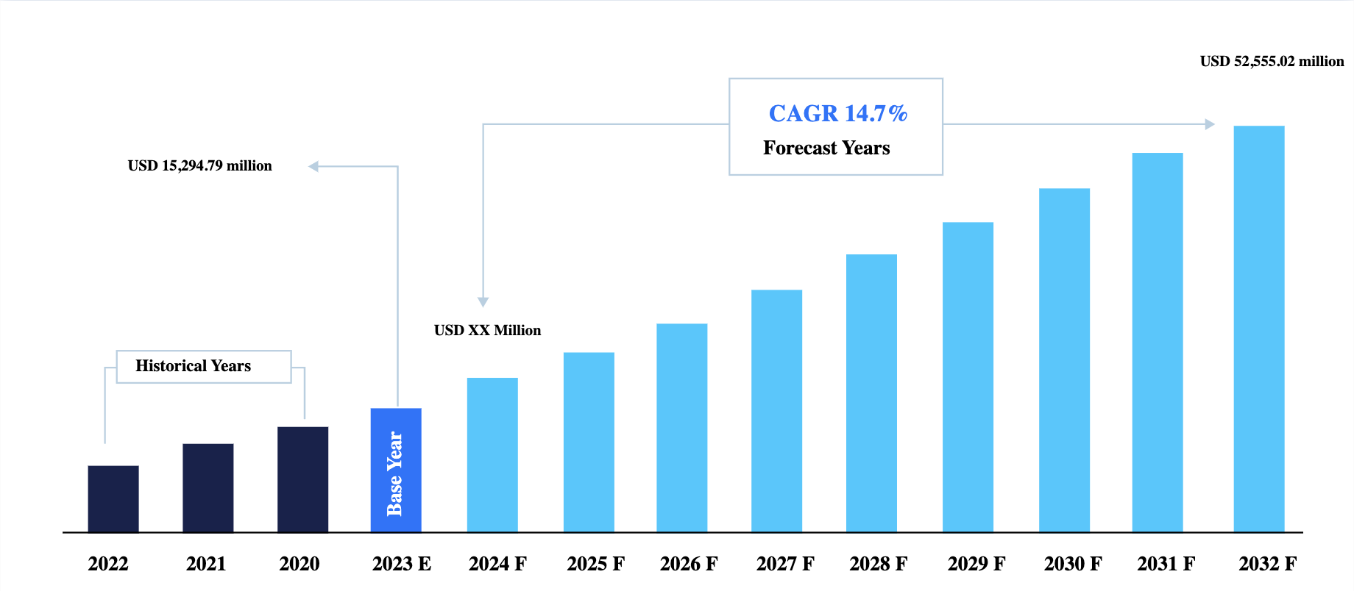
- More than 90% of US banks have installed a core banking system, with cloud-based solutions becoming increasingly popular.
- The average cost of developing a core banking system for small banks ranges from $500,000 to $1 million, whereas bigger institutions might spend more than $10 million.
- More than 60% of US banks are moving to cloud-based core banking systems due to the requirement for scalability, flexibility, and cost-effectiveness.
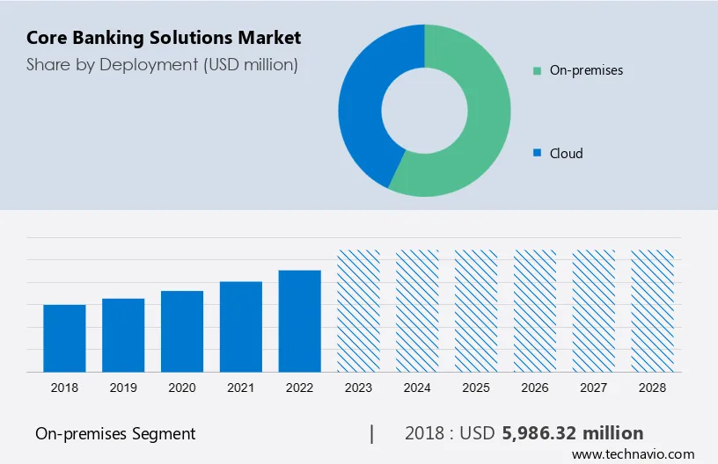
- Banks that install core banking technologies generally save operating expenses by up to 30%.
Conclusion:
Core banking systems provide the foundation of modern banking operations, allowing banks to provide efficient, secure, and customer-focused services. In the United States, the introduction of modern technology and the shift to cloud-based solutions are causing substantial changes in the fundamental banking sector. By addressing cost, complexity, and cybersecurity issues, banks can fully reap the benefits of contemporary core banking technology and maintain a future-ready banking environment.

